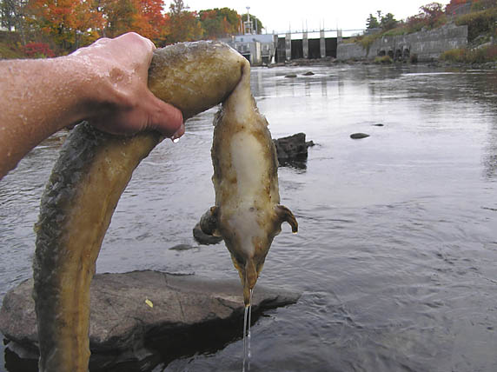

Green Power in Action!

Turbine Mortality-American Eel, Benton Falls Dam, Sebasticook River 2004

Photo: Watts Brothers

